## Graph showing how surface area-to-volume (SA:V) ratio affects diffusion rate

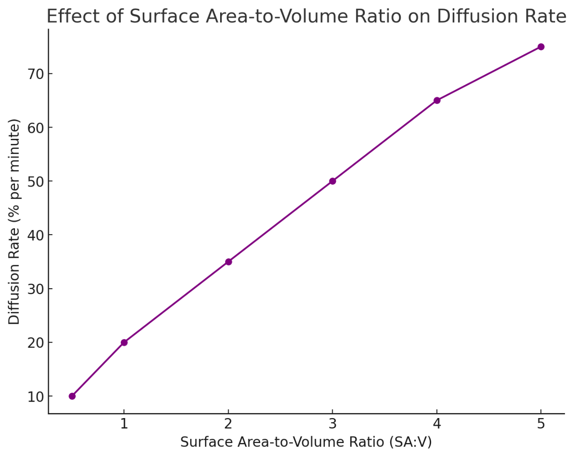

## 

## Data Table: Diffusion Rate at Different SA:V Ratios

| **Surface Area-to-Volume Ratio (SA:V)** | **Diffusion Rate (% per minute)** |
| --- | --- |
| 0.5 | 10 |
| 1.0 | 20 |
| 2.0 | 35 |
| 3.0 | 50 |
| 4.0 | 65 |
| 5.0 | 75 |

## ****Questions and Sample Answers****

### **Quantitative and Identification (30%)**

1. **Identify:** What is the diffusion rate when the SA:V ratio is 3?

**Answer:** The diffusion rate is 50% per minute.

1. **Calculate:** What is the percentage increase in diffusion rate when the SA:V ratio rises from 1 to 3?
   * **Answer:** The diffusion rate increases from 20% to 50%. The percentage increase is:

(50−20)/20×100=150%\frac{50 - 20}{20} \times 100 = 150\%2050−20​×100=150%

1. **Determine:** If a cell has an SA:V ratio of 4, how quickly does diffusion occur?
   * **Answer:** Diffusion occurs at 65% per minute.

### **Patterns, Relationships, and Limitations (30%)**

1. **Classify:** Group the data into low, medium, and high SA:V categories. How does diffusion change across these groups?
   * **Answer:**
     + Low SA:V (0.5–1.0): Slow diffusion (10–20%).
     + Medium SA:V (2.0–3.0): Moderate diffusion (35–50%).
     + High SA:V (4.0–5.0): Fast diffusion (65–75%).  
       Higher SA:V ratios lead to faster diffusion!
2. **Compare:** How does diffusion change between an SA:V ratio of 2 and 4?
   * **Answer:** Diffusion rate increases from 35% to 65%. The higher ratio allows more efficient exchange of materials.
3. **Identify:** What pattern emerges as SA:V ratio increases? Why might this be important for cells?
   * **Answer:** As SA:V increases, diffusion rate rises. This is crucial for cells because smaller cells with higher SA:V ratios can exchange nutrients and wastes more effectively.

### **Conclusions and Justifications (40%)**

1. **Infer:** Predict what the diffusion rate might be at an SA:V ratio of 6.
   * **Answer:** Based on the trend, the diffusion rate would likely be around 85–90% per minute.
2. **Justify:** Why are cells typically small? Use the data to support your answer.
   * **Answer:** Cells are small to maximize their SA:V ratio, ensuring faster diffusion rates for efficient nutrient uptake and waste removal. If cells were too large, diffusion would be too slow to meet metabolic demands.
3. **Draw a Conclusion:** What factor is most important for efficient diffusion: surface area, volume, or the SA:V ratio itself?
   * **Answer:** The SA:V ratio is the most important factor. Even if surface area increases, if volume grows faster, diffusion becomes inefficient. A high SA:V ratio ensures materials can quickly reach all parts of the cell.